**NAME : JASVANTH S**

**REGISTER NUMBER : 192210311**

**SUBJECT CODE: CSA0323**

**SUBJECT: DATA STRUCTURES WITH MULTITASK PROGRAMMING**

**1)ADDITION IN C PROGRAM**

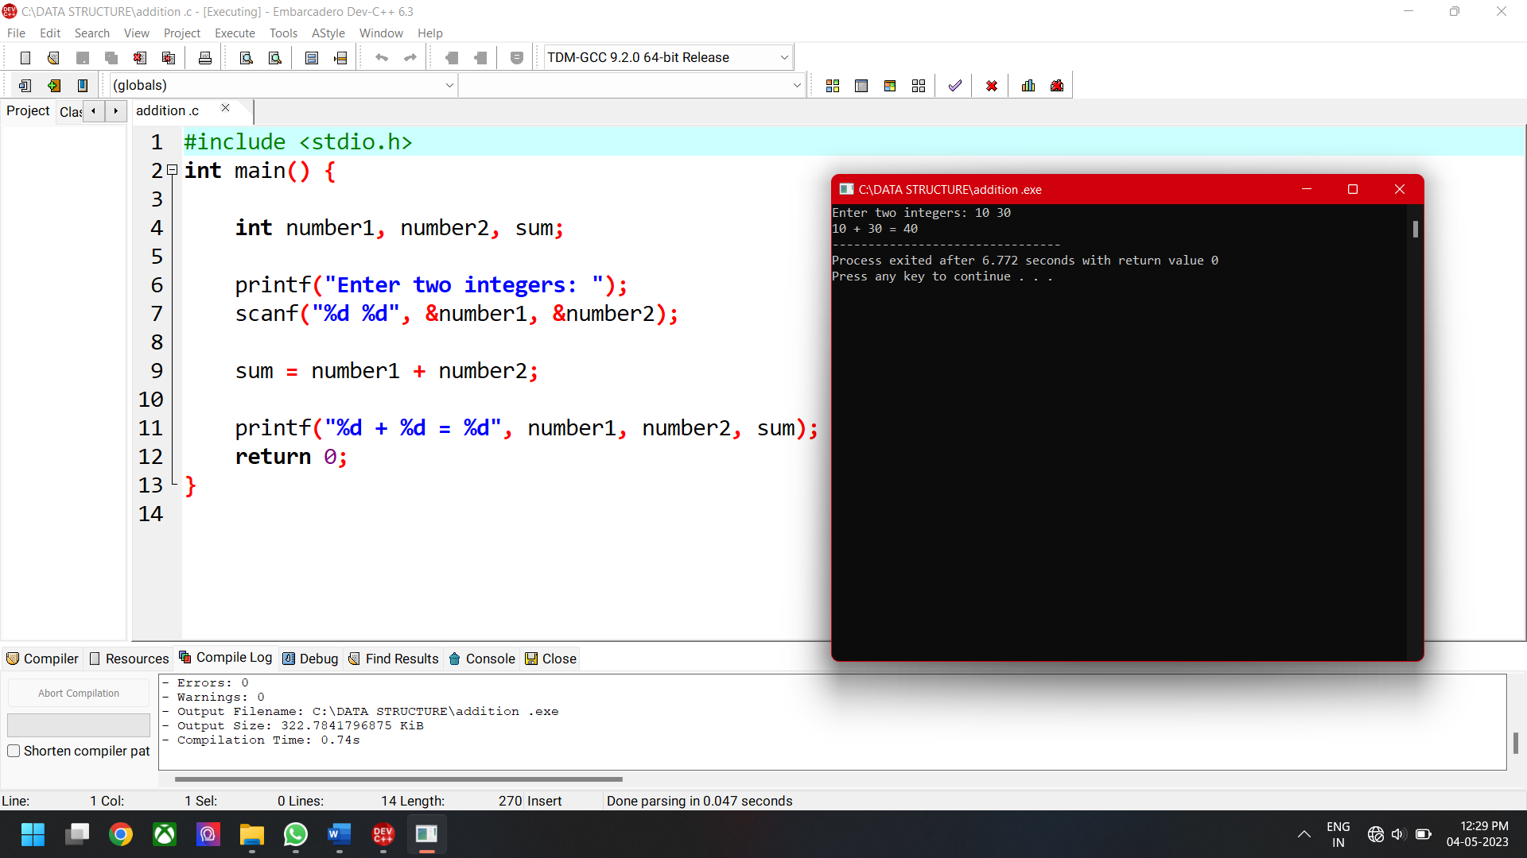

**2) ARITHMATIC OPERATION IN C PROGRAM**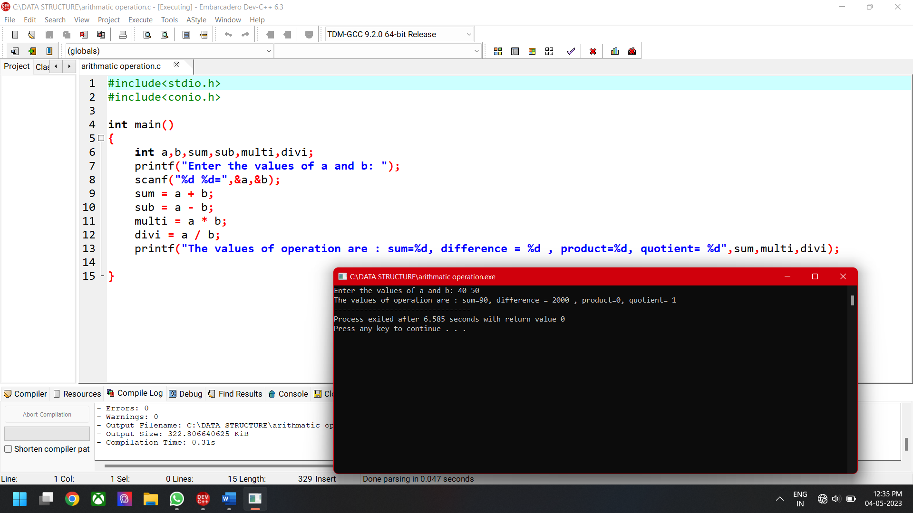

**3)CHECK THE ELEMENT IS ODD OR EVEN USING C PROGRAM**

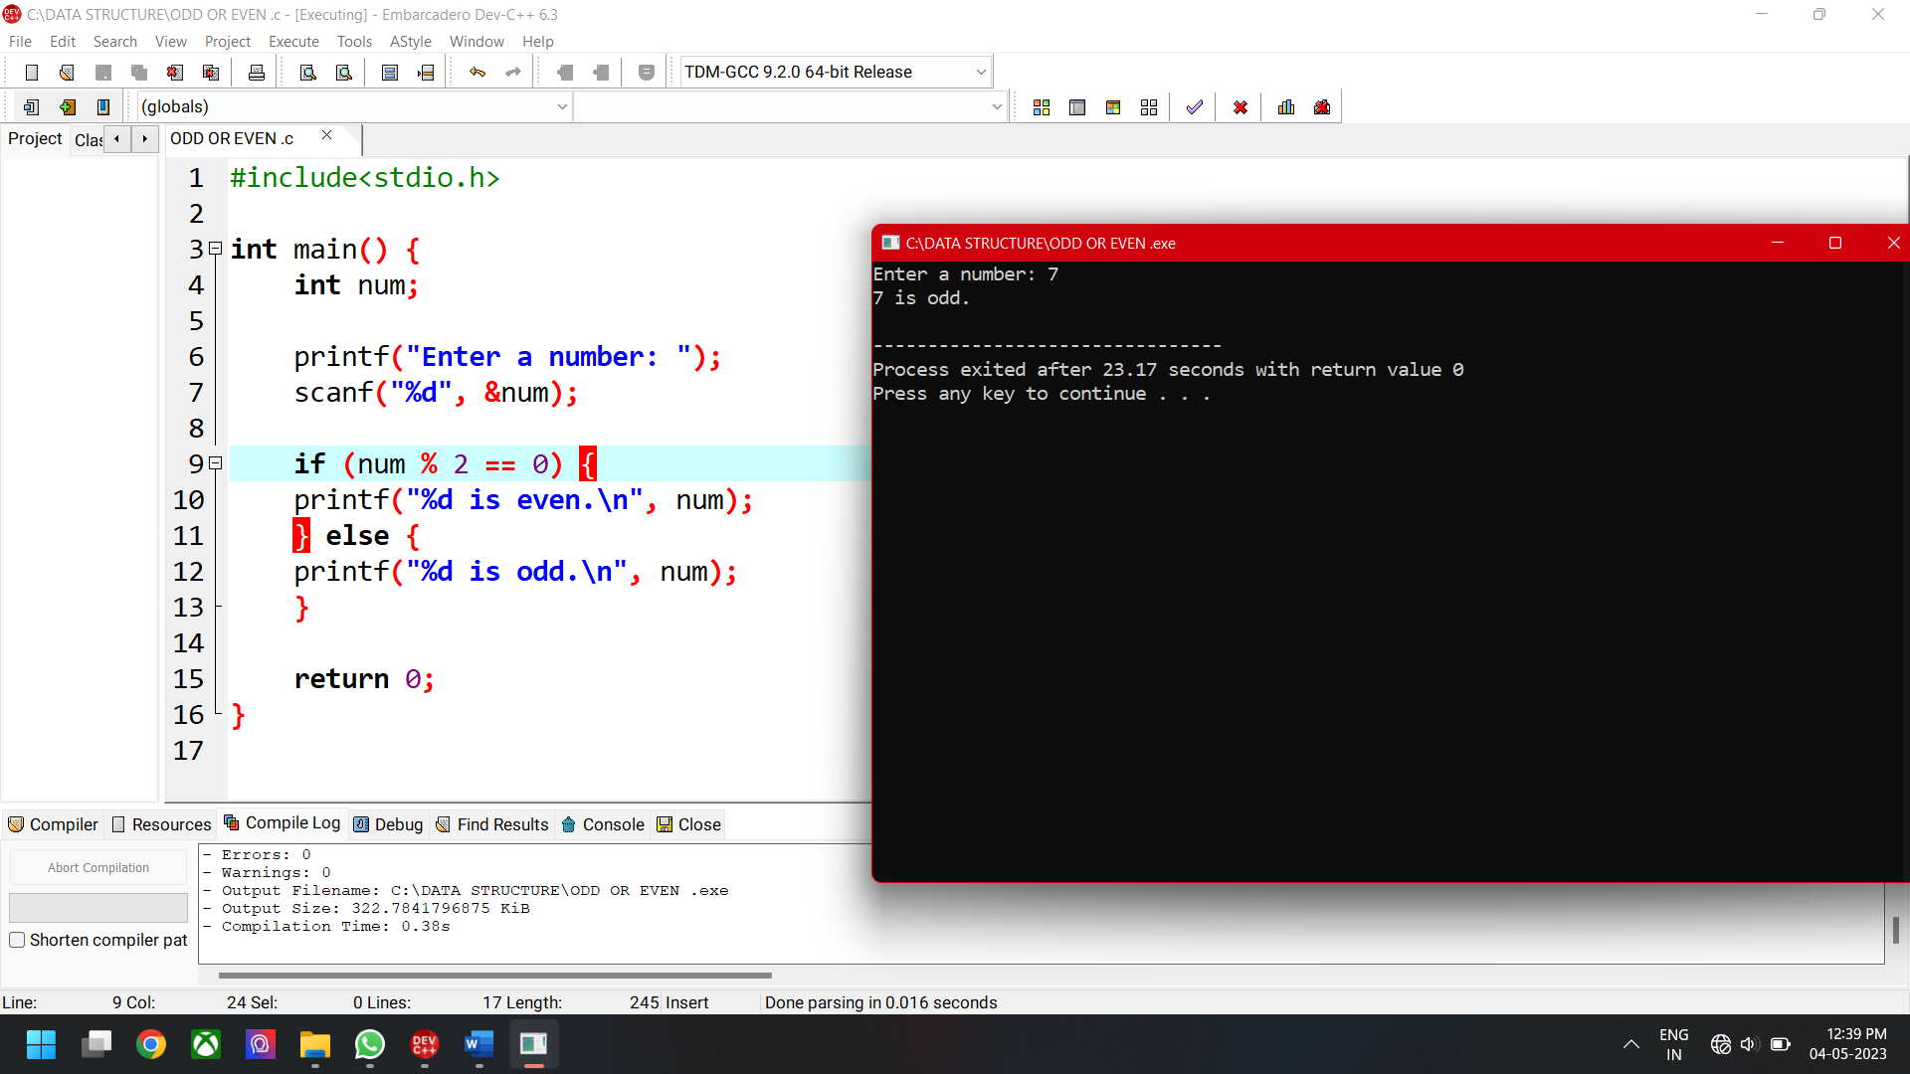

**4)ARITHMATIC OPERATION IN C PROGRAM USING STATIC INITIALIZATION**

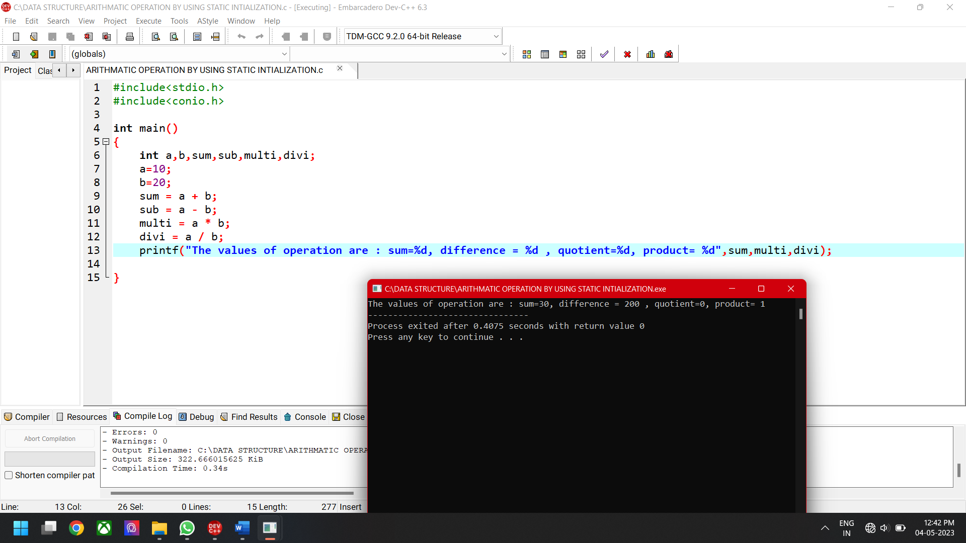

**5) CHECKING THE BIGGEST BETWEEN TWO NUMBERS**

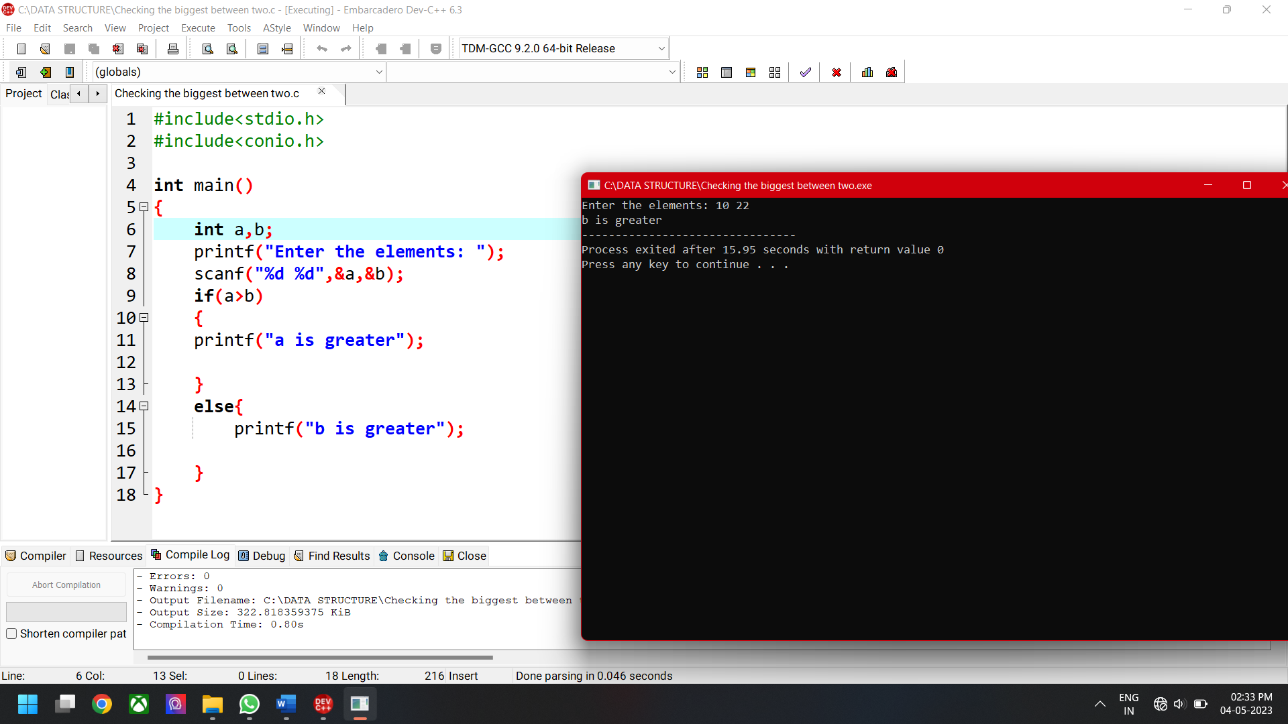

**6) MARKS AND GRADE IN C PROGRAM**

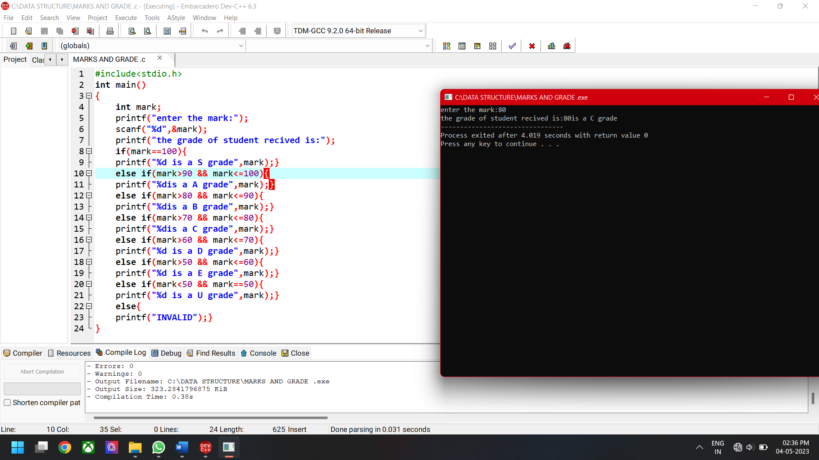

**7) FINDING THE BIGGER VALUE USING C PROGRAM**

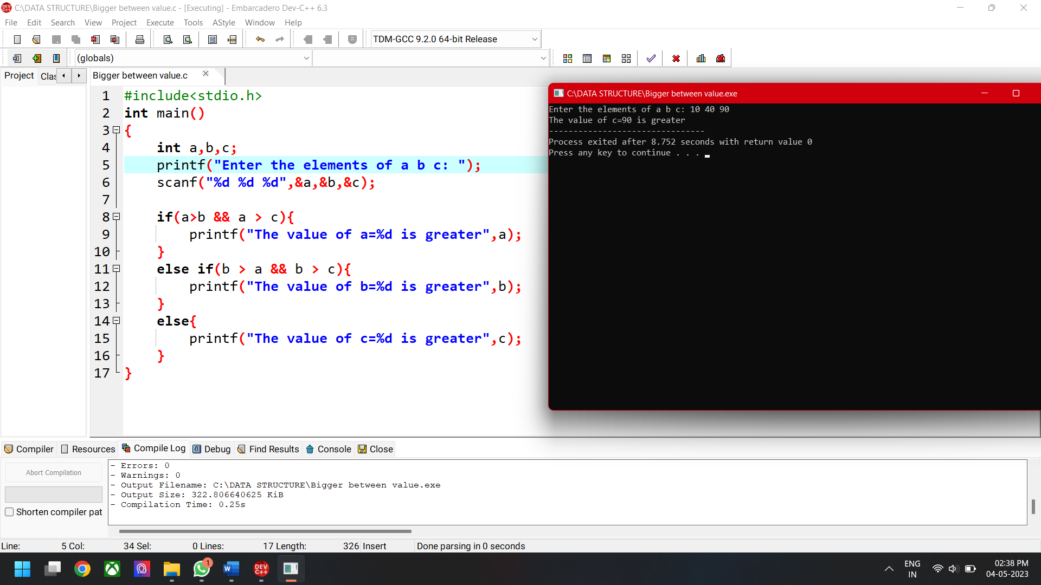

8)PRINT NUMBERS FROM 1 TO 10

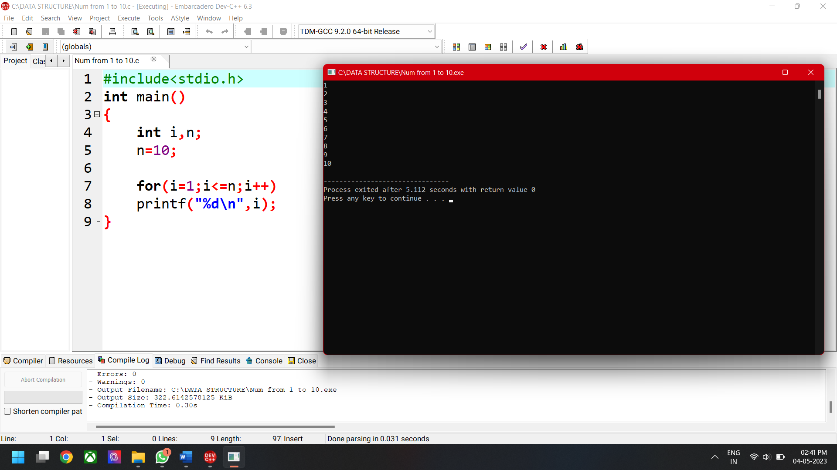

9)PRINT NUMBERS FROM 10 TO 1 USING C PROGRAM

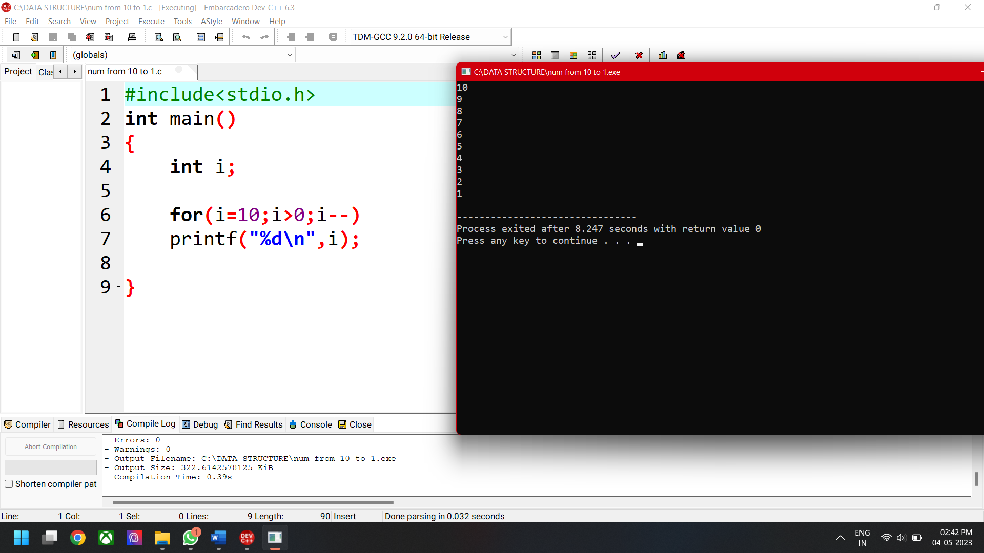

10) PRINT WELCOME STATEMENT USING LOOPING IN C PROGRAM

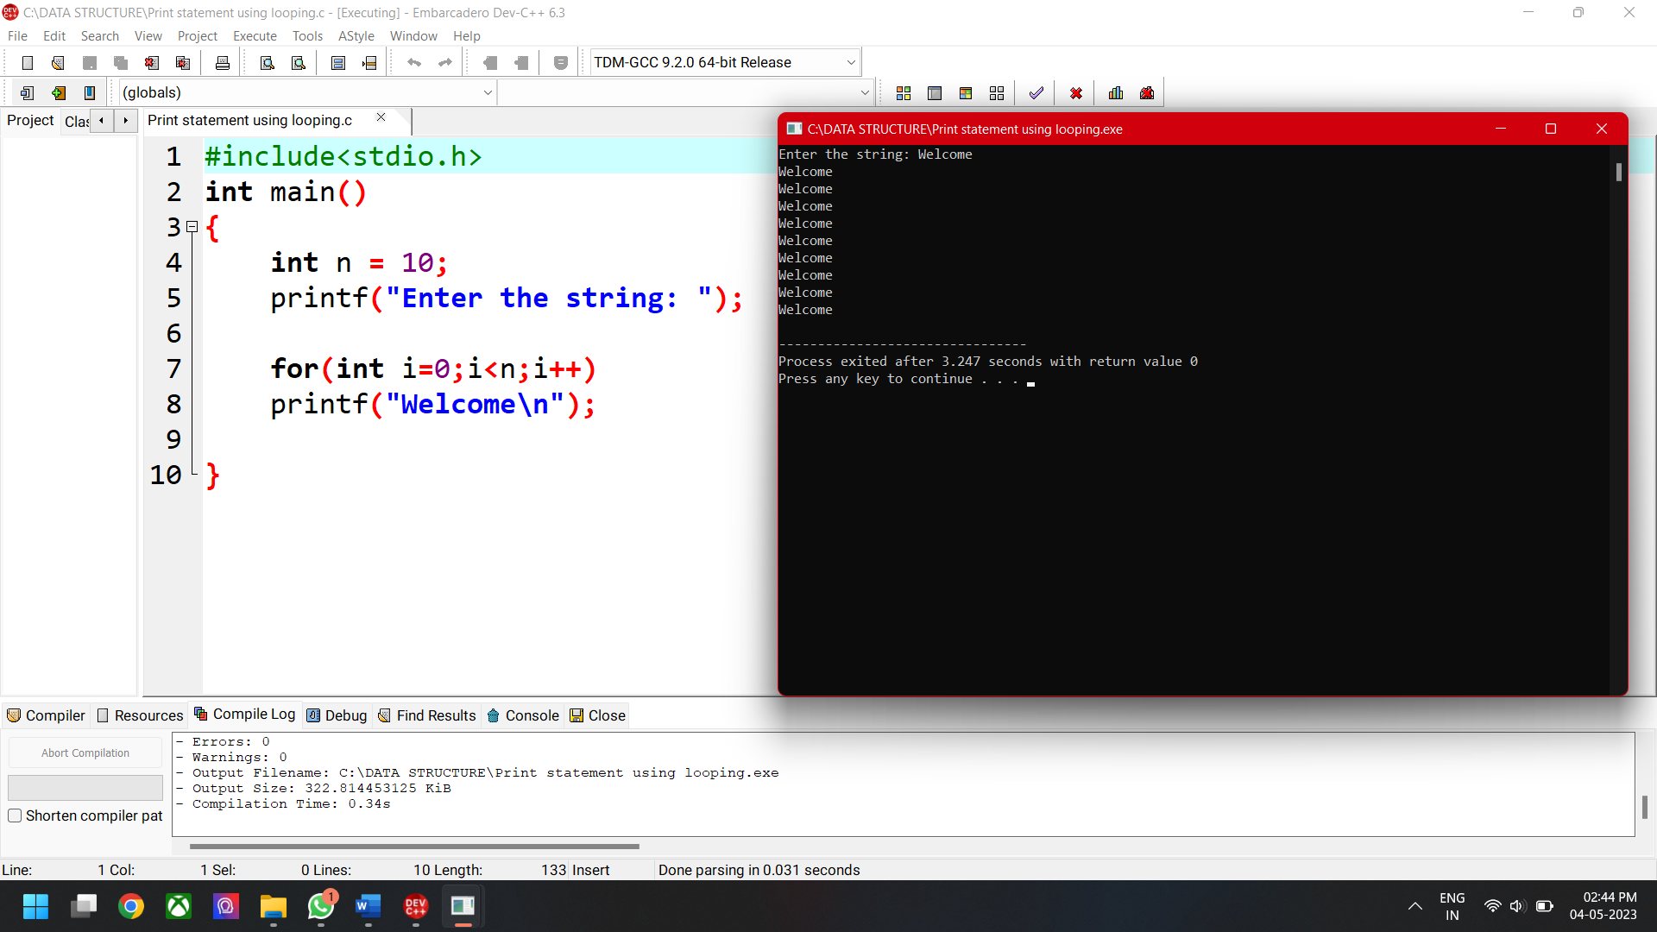

11) SUM OF DIGITS USING WHILE LOOP

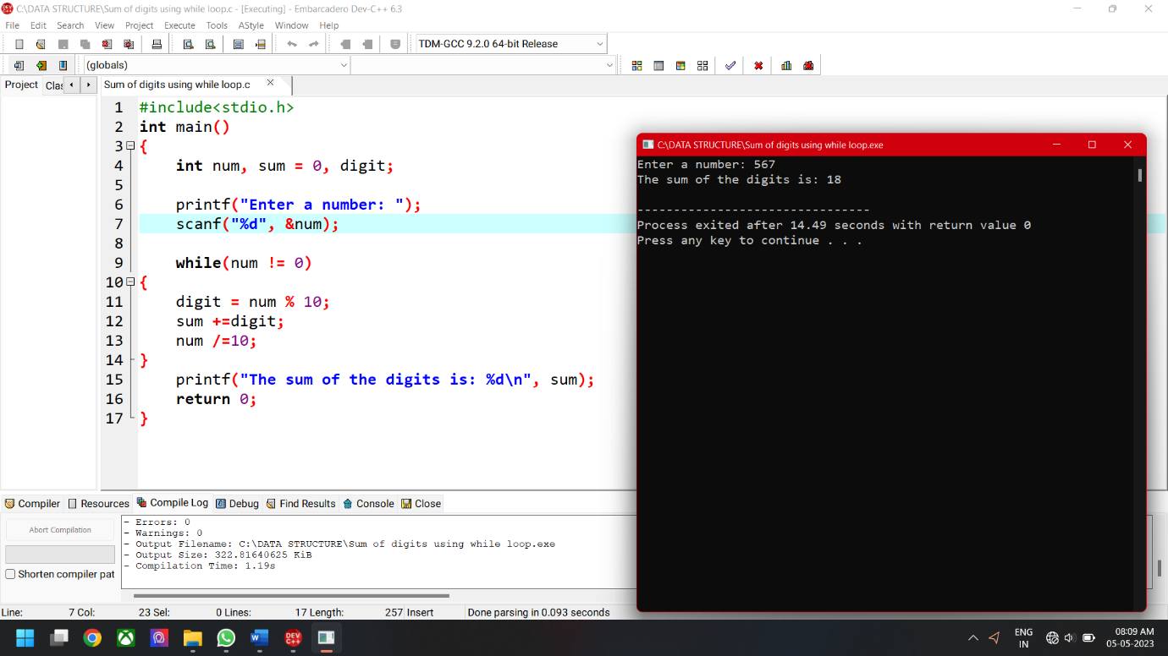

12) C PROGRAM TO PRINT FIRST ‘N’ NUMBERS USING DO-WHILE LOOP

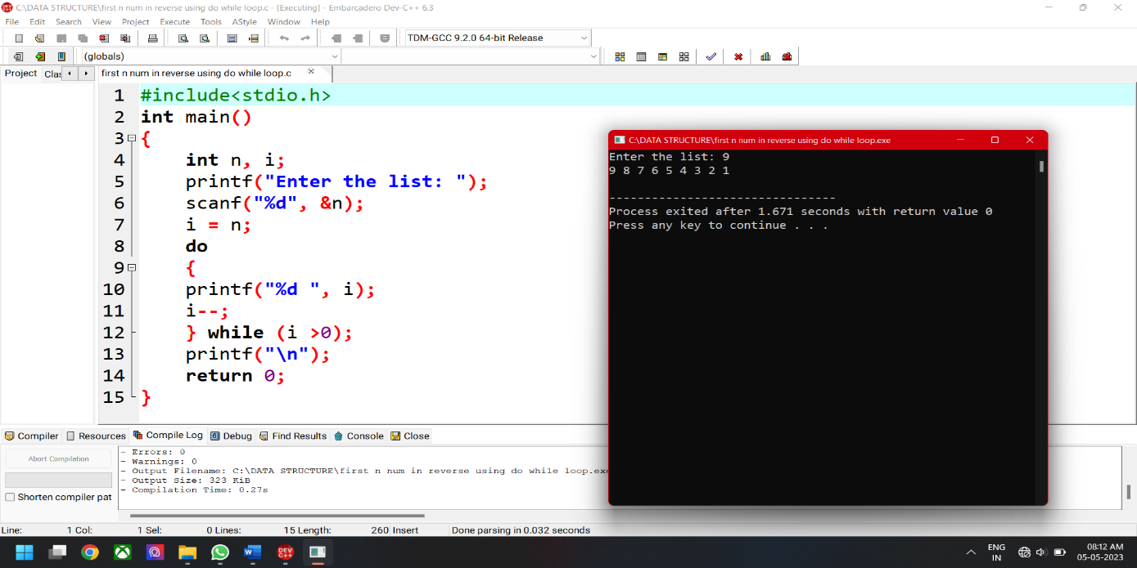

13) INITIALIZE ARRAY WITH 10 ELEMENTS AND PRINT THE SAME

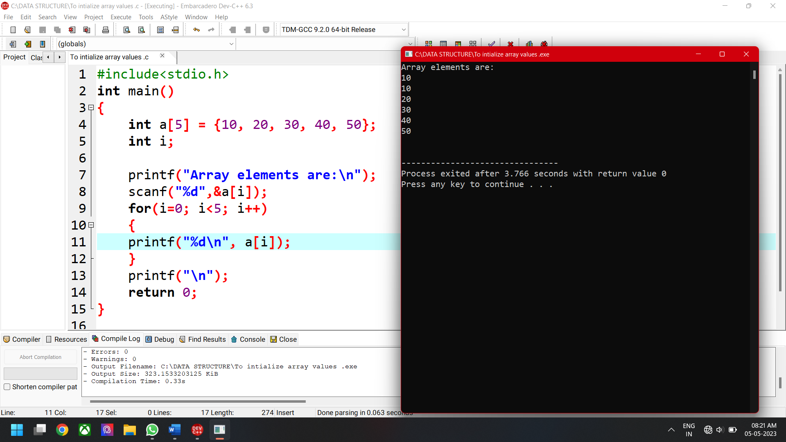

14) SUM OF ARRAY ELEMENTS

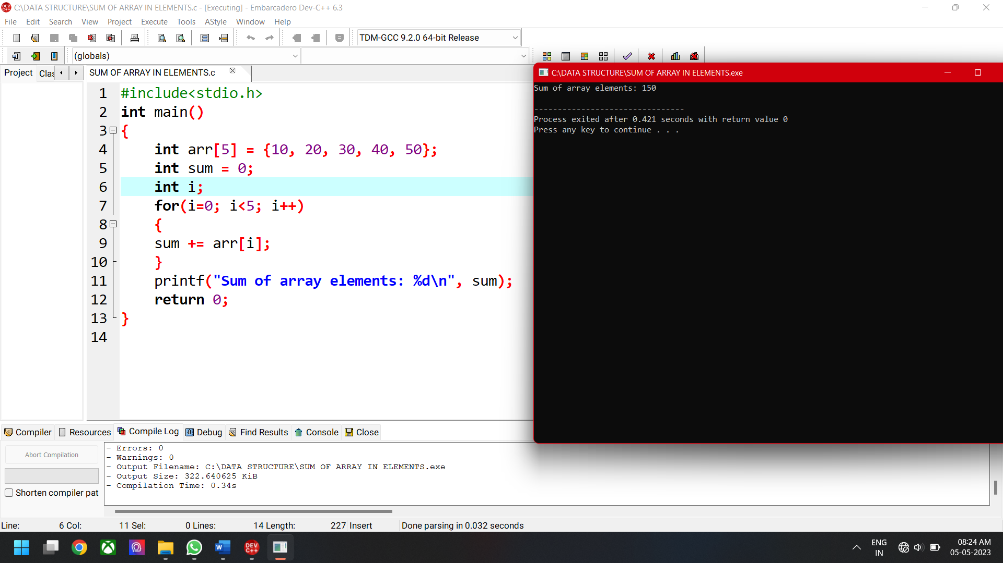

15)MINIMUM ELEMENT IN ARRAY USING C PROGRAM

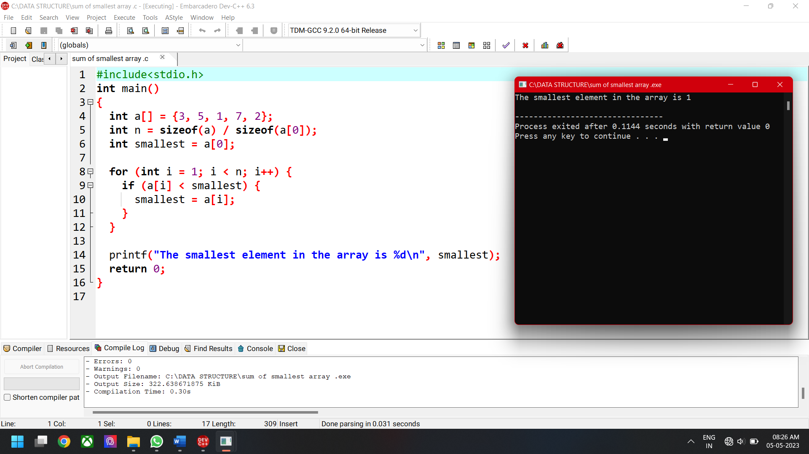

16) SUM OF MAXIMUM ELEMENT IN ARRAY

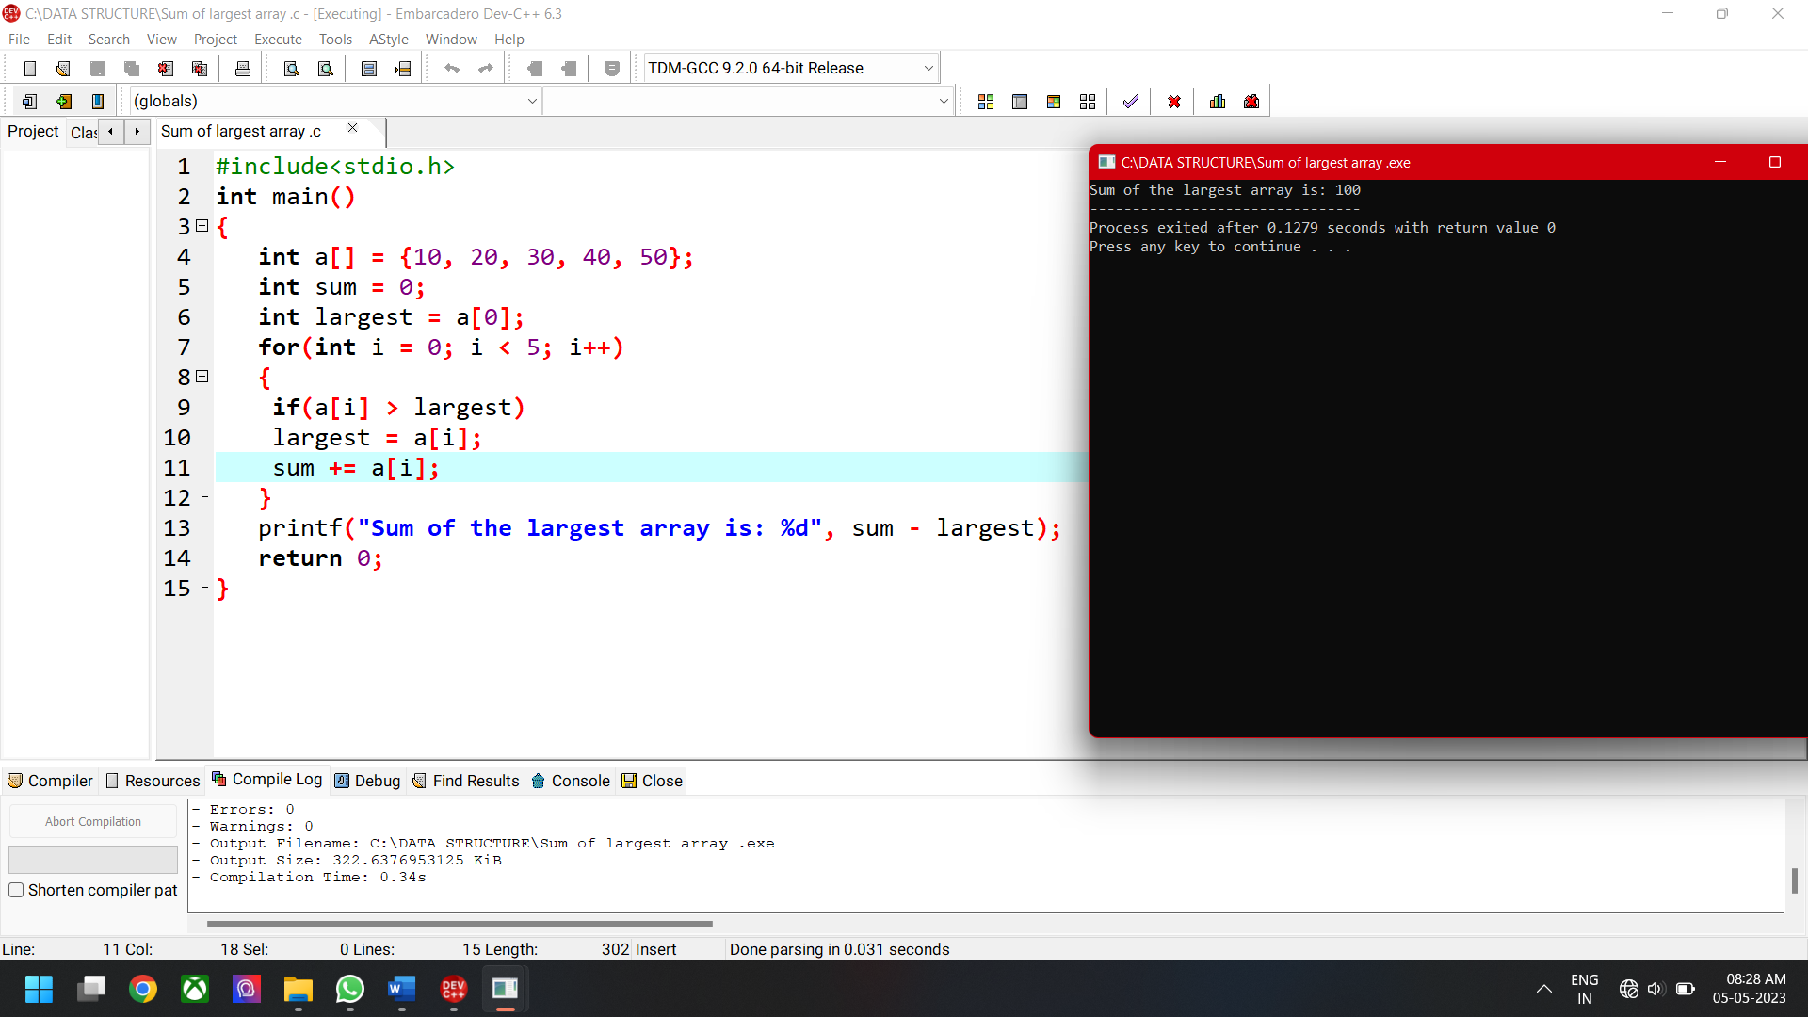

17) SEARCH ELEMENT IN ARRAY USING LINEAR SEARCH IN C PROGRAM

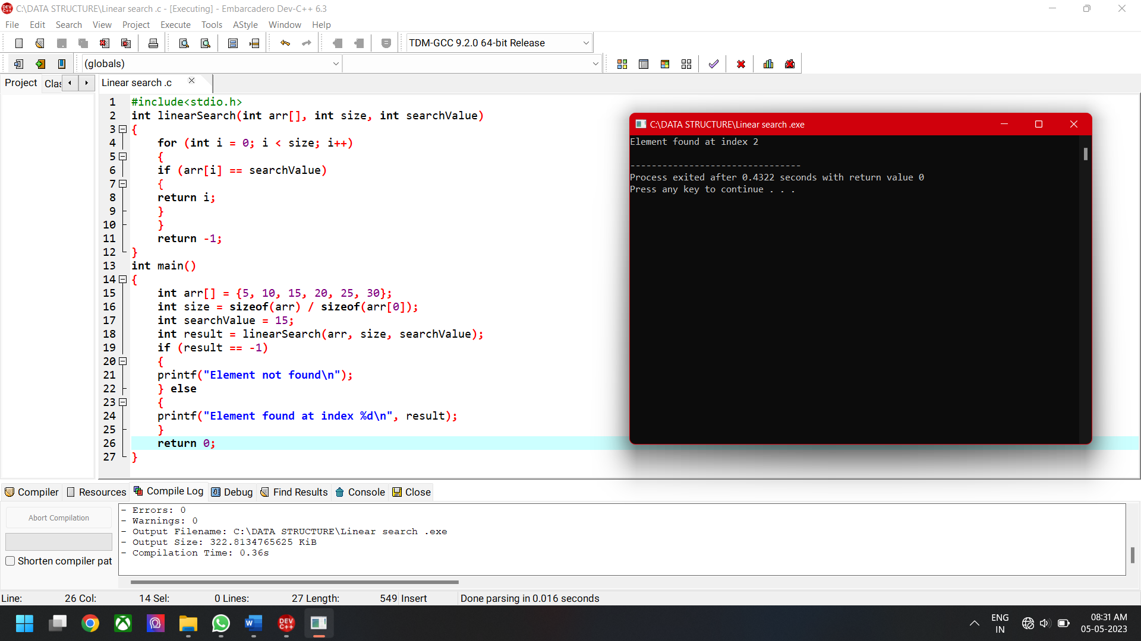

18) GET 5 NUMBERS FROM USER AND SUM IT USING WHILE LOOP

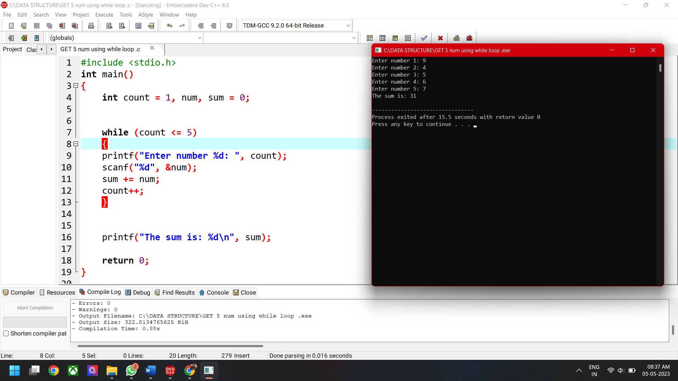

19) INSERTING THE ELEMENT USING C PROGRAM.

